**Name: Anish Ashok Sharma Sap id: 60003220045**

**Branch: Information Technology Div: D/IT1**

**Course**: **Object Oriented Programming using Java**

# Experiment no. 9

Aim: To implement Abstract classes and packages

**Problem Statement 1:**

Write an abstract class program to calculate area of circle, rectangle and triangle.

Code:

import java.util.*;

abstract class Circle

{

abstract void area(int r);

abstract void rectangle(int l,int b);

abstract void triangle(int base,int height);

}

class Example extends Circle

{

public void area(int r)

{

System.out.println("Area Circle:"+(22/7)*r*r);

}

public void rectangle(int l,int b)

{

System.out.println("Area Rectangle:"+l*b);

}

public void triangle(int base,int height)

{

System.out.println("Area Triangle:"+((base*height)/2));

}

}

class AreaAbstract

{

public static void main(String args[])

{

Example obj1=new Example();

Scanner obj=new Scanner(System.in);

System.out.println("Enter radius");

int r=obj.nextInt();

obj1.area(r);

System.out.println("Enter length and breath");

int l=obj.nextInt();

int b=obj.nextInt();

obj1.rectangle(l,b);

System.out.println("Enter base and height");

int base=obj.nextInt();

int height=obj.nextInt();

obj1.triangle(base,height);

}

}

Output :

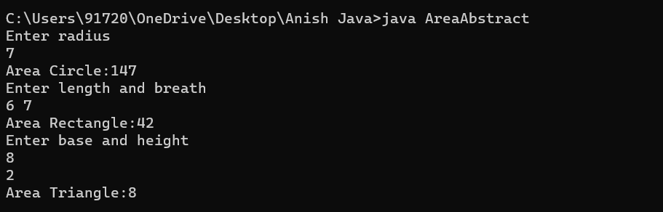

**Problem Statement 2:**

WAP to create a package called vol having Cylinder class and volume (). WAP that imports this package to calculate volume of a Cylinder.

Code:

package volume;

public class Cylinder

{

public void volume(int r,int h)

{

System.out.println("Volume of cylinder is "+(3.14*(float)r*(float)h));

}

}

import volume.Cylinder;

class VCylinder

{

public static void main(String[] args)

{

Cylinder obj=new Cylinder();

obj.volume(5,3);

}

}

Output

